CIF Sweden

Professional Exchange Program April 5 – May 4 2024
CIF Sweden invites social workers and other professionals working in social services to participate in a four weeks program including introduction to the program, orientation to Swedish Welfare System, Social Policy and Social Work and fieldwork experience.

CIF Sweden is a national branch of CIF, Council of International Fellowship, and was formed 1961. CIF-Sweden had its first program in 1978. CIF is a private, nonprofit, politically and religiously independent organization. The goal is to promote professional, cultural and educational exchange for social workers and professionals working in social services. The CIF-Sweden program is coordinated by volunteers, former CIF participants and with help from friends of CIF.

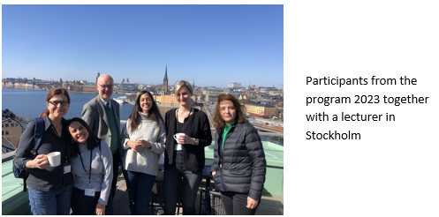

Introduction
The program begins in Stockholm where the participants live together the first weekend and have a chance to get to know each other. Introduction of the program and some information about Stockholm, Swedish life and culture are shared. During these days there will be professional exchange between the participants by sharing information about their home country and profession. The participants move to host family living after the first weekend.

Orientation Program
This part of the program takes place in Stockholm and gives an orientation and overview about Sweden, its political, educational and social welfare system. Special emphasis is placed upon social work, social policy in Sweden and Swedish way of life. The program is a combination of seminars, visits to Governmental institutions as well as Nongovernmental agencies and cultural events. Participants are involved in discussions to enhance the
understanding of Swedish culture.

An important part is the cultural and professional exchanges within the group of participants including their experience and sharing in a multicultural group.

Individual program
An individual placement based on the participant’s field of social work. During this part of the program the participants will to another city in Sweden and live in host families. The field placement is, due to the language barrier, based on agency visits, observations and meetings with colleagues that contributes to the cross-cultural exchange.

Evaluation and Farewell Party
During the last week participants return to Stockholm for some additional agency visits and hostfamily living. The program ends with an evaluation and sharing of experiences and a Farewell Party.

Relevant information

- Applicants must have a minimum of 2 years of professional experience in the social work field.
- The number of participants is 4 - 6.
- CIF Sweden has no program fee.
- Domestic travel and room and board is provided by CIF-Sweden.
- International travel, travel expenses from and to the airport and medical insurance is the participant’s responsibility.

How to apply

- The deadline for application is November 13, 2023.
- The application form is found on CIF Sweden´s or CIF International´s website.
- Your application must go through your CIF national branch or Contact Person in your country.
- Send application directly to CIF-Sweden only if there is no CIF branch or Contact Person in your country.

For more information visit:
www.cifsweden.se or www.cifinternational.com
E-mail: info@cifsweden.se

